**AAAS Membership Verification**

# **OVERVIEW**

This document describes the setup requirements and usage of the AAAS membership verification codebase.

The codebase consists of two components that work together to complete the verification process. These include:

1. The Javascript SDK to be used on the client’s frontend
2. The backend that handles the identity verification.

These components will be discussed in detail in the next section.

# **COMPONENTS**

## **Javascript SDK**

The javascript SDK is located in the public/sdk directory. Before the SDK can be used, you need to set the origin of the authentication backend.

### **Setting the authentication backend origin**

1. Open the authsdk.js file
2. Set the origin on line 4

Data attributes should be added to the elements that when clicked, will trigger the authentication process.

The SDK should be included in the client’s page and initialized with a redirect url.

When the user clicks on the element, a popup window opens and the user begins the authentication process.

After a successful authentication, the pop up closes and the user is redirected to the redirect url that was supplied during the initialization of the SDK.

A JWT containing the user's email, ISBN number and the selected author will be passed as a query parameter named **data** to the supplied redirect url as in the example below.

<https://rightsplatform.com/articles?data=eyJhbGc...VCJ9.eyJzdW...IyfQ.SflK...sw5c>

The JWT should be verified with the signing secret.

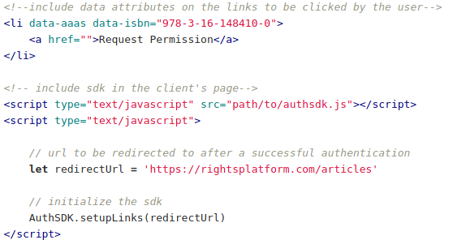

Code snippet showing usage of the SDK

## **Backend**

Setting up the backend will require a knowledge of PHP and [Laravel](https://laravel.com/).

### **Changing the identity verification API**

1. Open the **AuthProcess** class located at app/Http/Controllers/AuthProcess.php
2. In the **login** method, modify the **apiEndpoint** and **requestBody** variables to conform with the desired authentication provider’s specifications.
3. Follow the instructions in the code comments and make other necessary modifications.

### **Adding the API endpoint for getting authors of an article**

1. Open the **AuthProcess** class located at app/Http/Controllers/AuthProcess.php
2. In the getAuthors method, add the necessary logic required for getting the articles authors from the isbn that has been retrieved from the session.
3. Follow the instructions in the code comments and make other necessary modifications.

### **Setting the JWT signing secret**

1. Open the .env file located in the projects root
2. Scroll to the bottom and set the JWT_SIGNING_SECRET to the desired secret